Grazioso Salvare Rescue Identification Dashboard
Ryan Eames
CS 340 – Client/Server Development
This project involved building a full-stack client/server dashboard for Grazioso Salvare, an organization that trains dogs for specialized rescue operations. The purpose of the application is to help identify potential search-and-rescue candidates using data from the Austin Animal Center. The system allows users to filter dogs by rescue category and dynamically analyze results through an interactive data table, a breed distribution chart, and a geolocation map. The final dashboard integrates MongoDB as the data model, a custom Python CRUD module as the controller, and the Dash framework as the web interface.
The dashboard launches in an unfiltered state and displays all available records from the database. The interactive data table supports sorting, filtering, pagination, and single-row selection. The breed distribution chart automatically reflects the current dataset displayed in the table. The geolocation map centers on Austin, Texas and updates based on the selected row in the data table. The Grazioso Salvare logo and the unique identifier “Ryan Eames | CS 340 Project Two” are visible on the dashboard at all times.
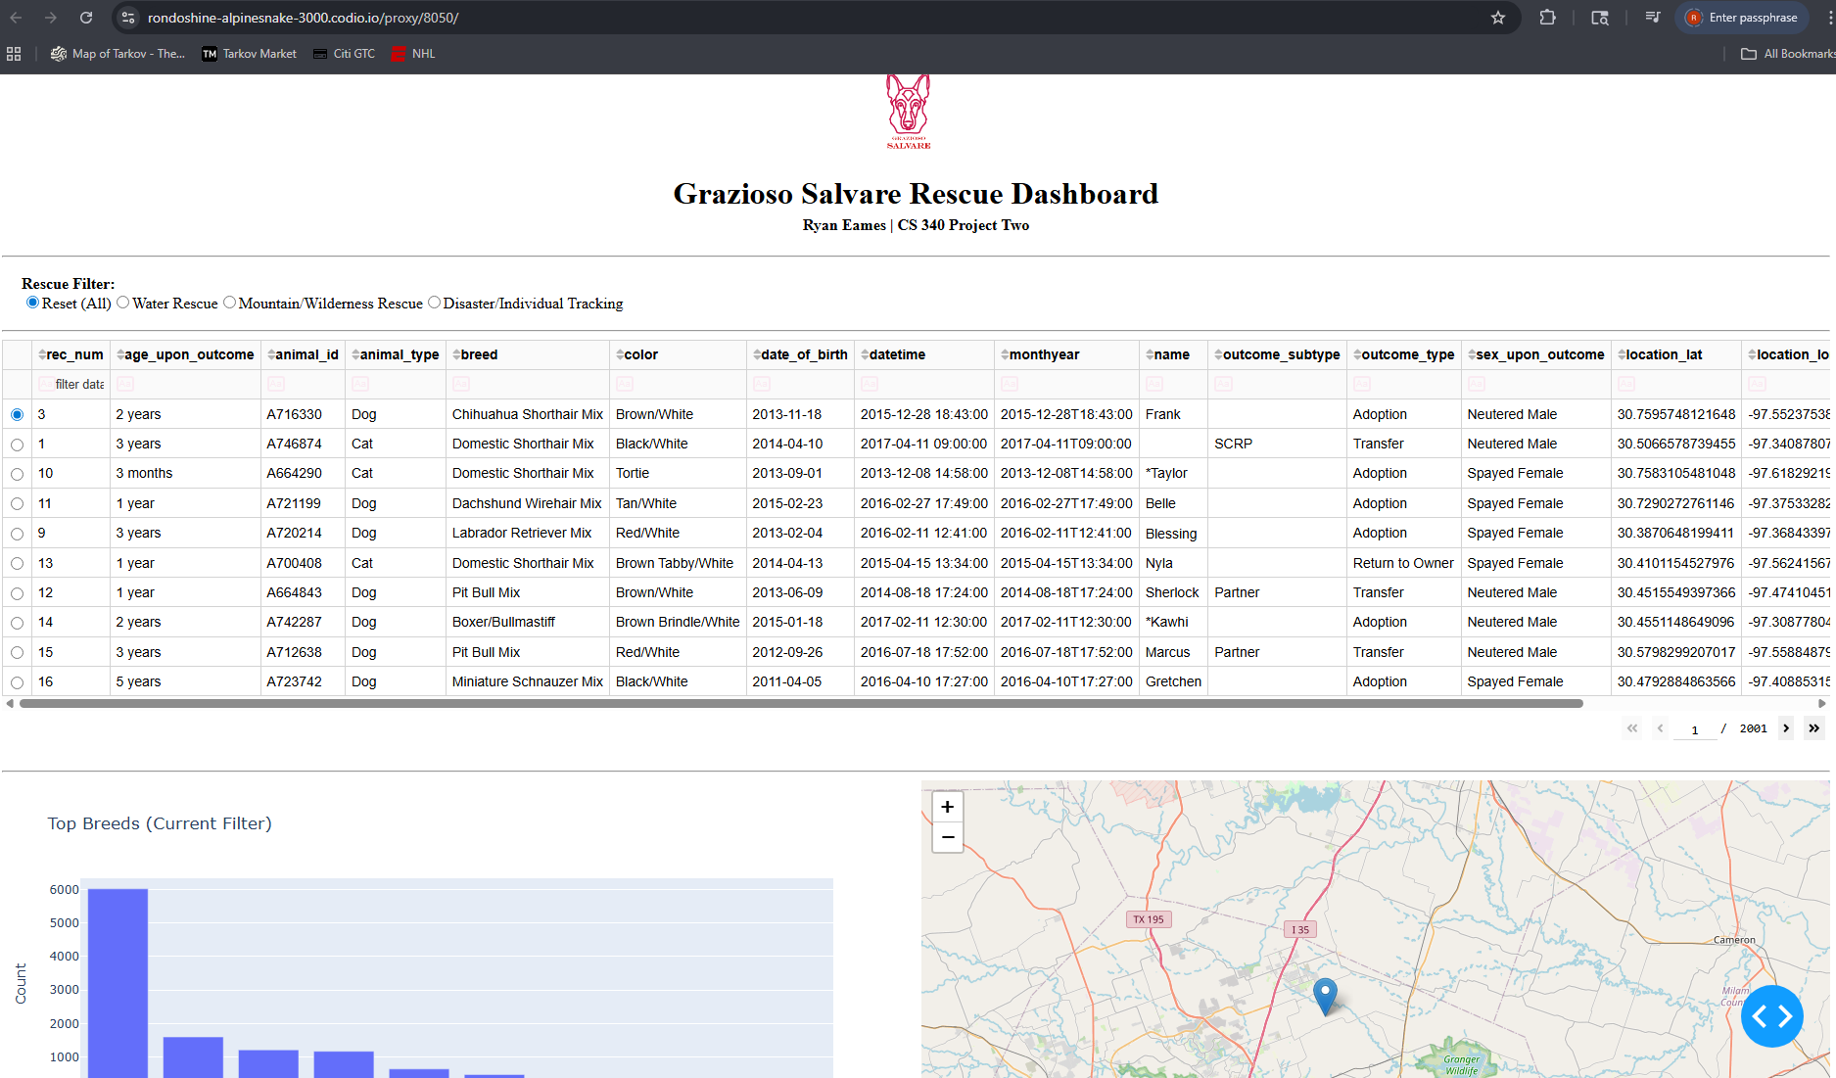
When the Water Rescue filter is selected, the application executes a MongoDB query using breed and age criteria defined in the project specifications. The data table updates immediately to show only qualifying dogs. The breed chart recalculates based on the filtered dataset, and the map updates to reflect the selected entry. This confirms that the controller logic and callbacks function correctly.
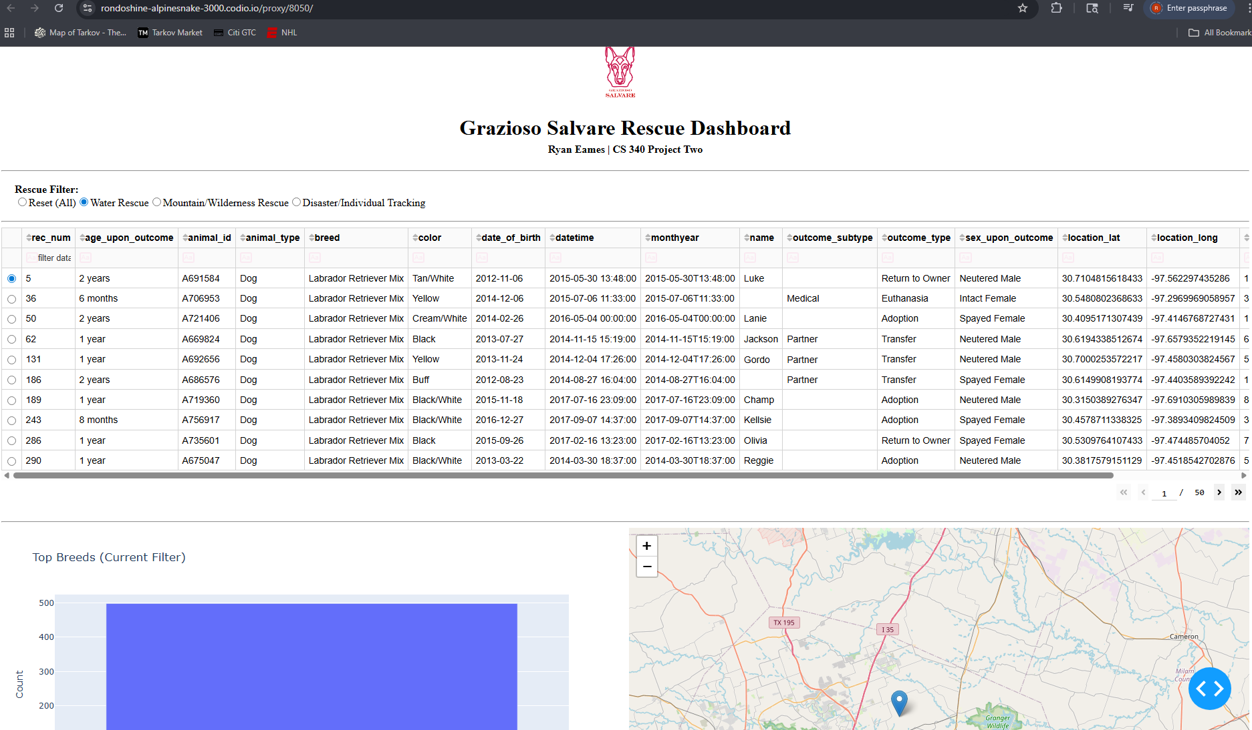
Selecting the Mountain/Wilderness Rescue option triggers a different MongoDB query aligned with the appropriate breeds and age requirements. All components update simultaneously without page reload. This demonstrates successful integration between the model, controller, and view layers.
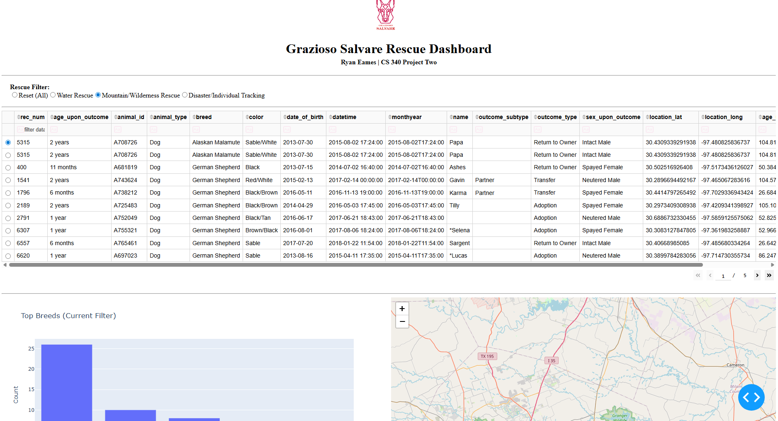
The Disaster/Individual Tracking filter functions in the same manner, retrieving only qualifying records and updating the visualizations dynamically. The consistent behavior across all filter options confirms stable callback implementation and proper database query construction.
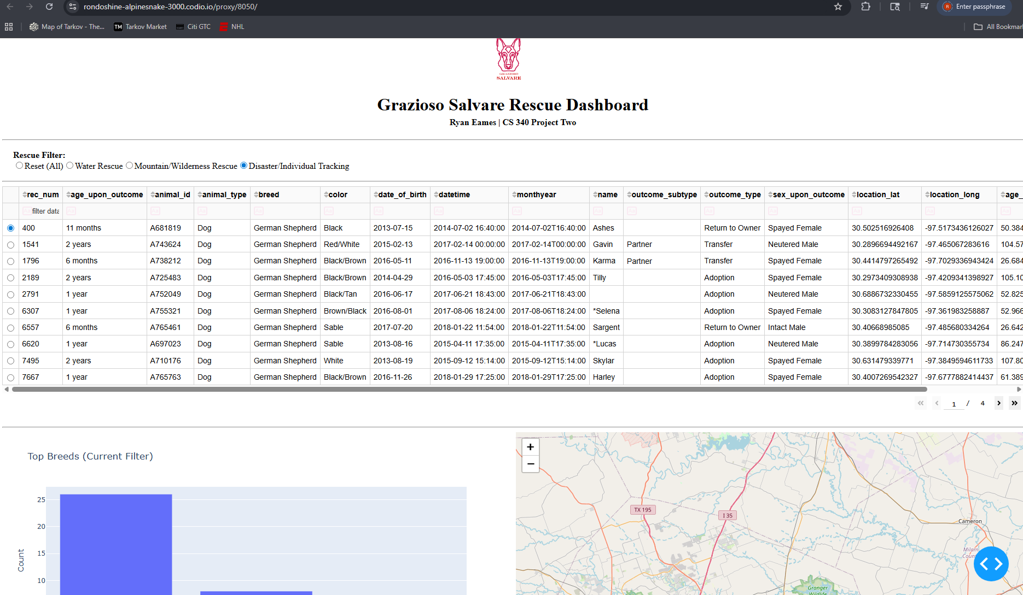
Selecting Reset restores the full dataset and returns the dashboard to its original state. This confirms that the application properly handles empty or default query conditions and maintains system stability.
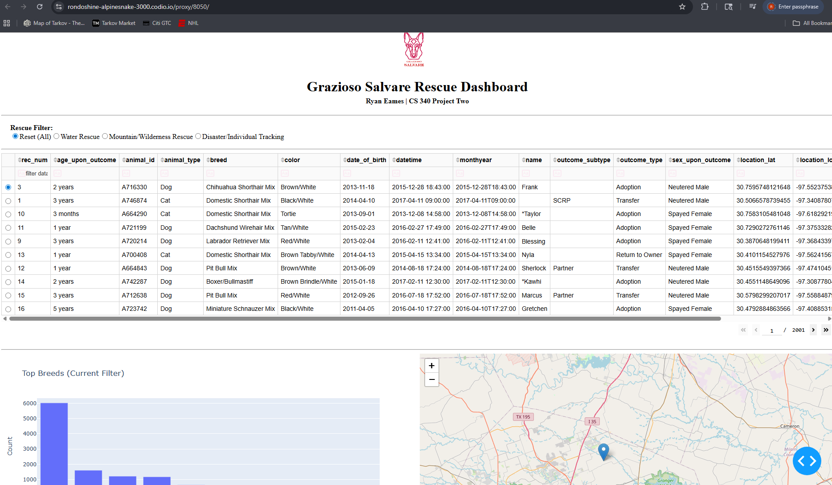
MongoDB was selected for this project because it stores data in flexible JSON-like documents, which integrate naturally with Python dictionaries and Pandas DataFrames. This structure allows dynamic querying without rigid schema constraints. MongoDB’s support for operators such as $in, $gte, and $lte made it efficient to implement rescue-category filtering based on breed and age criteria. The custom CRUD Python module separates database logic from the user interface, improving maintainability and supporting the MVC design pattern.
The Dash framework was used to build the web interface because it allows interactive web applications to be developed entirely in Python. Dash supports reactive callbacks that update components automatically when inputs change, eliminating the need for JavaScript. Plotly Express was used to generate the breed distribution chart, and Dash Leaflet was used to create the geolocation map that displays intake locations.
The development process began with importing the Austin Animal Center dataset into MongoDB and validating connectivity through the CRUD module. The dashboard layout was then constructed using Dash components. Radio button filtering options were implemented, and MongoDB queries were written to support each rescue category. Callbacks were created to update the data table, chart, and map dynamically. After debugging and validation, screenshots were captured to document functionality.
Several challenges were encountered during development. MongoDB’s _id field caused issues in the Dash DataTable because it uses the ObjectId data type, which required explicitly removing the column before rendering. Managing multiple callbacks required ensuring that data was consistently converted into Pandas DataFrames before being passed to dashboard components. Image encoding for the logo initially produced an error due to incorrect file mode usage, which was resolved by reading the file in binary mode. Each issue was resolved through systematic debugging and validation.
To reproduce this project, install MongoDB locally and import the Austin Animal Center dataset into a database named aac. Create a user named aacuser with authentication credentials. Install required Python packages including dash, plotly, pandas, pymongo, dash-leaflet, and jupyter-dash. Place the AnimalShelter.py file in the same directory as ProjectTwoDashboard.ipynb, ensure the logo file is present, and run the notebook to launch the Dash server.
This project demonstrates the practical application of database systems principles in a real client/server environment. The completed dashboard integrates data storage, filtering logic, and interactive visualization into a cohesive system that supports operational decision-making for rescue dog identification.

